 | 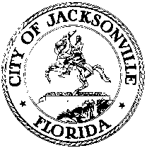
 | OFFICE OF THE CITY COUNCIL
ANNA LOPEZ BROSCHE  PRESIDENT  JACKSONVILLE CITY COUNCIL  OFFICE (904) 630-1452 |  | SUITE 425, CITY HALL  117 WEST DUVAL STREET  JACKSONVILLE, FLORIDA  32202
TASK FORCE ON OPEN GOVERNMENT
AGENDA
May 9, 2018
Lynwood Roberts Room
1:00 pm

Introductions

Media Panel (Confirmed)
AG Gancarski-Florida Politics
Claire Goforth-Folio Weekly
Jessica Palombo-WJCT
Karen Mathis and David Cawton-Financial News & Daily Record
Mary Kelly Palka-The Florida Times-Union
Kent Justice-WJXT
Closing Comments
Discussion and Planning
Public Comment

Chairs: Hank Coxe and Dr. Sherry Magill
Members: Ywana Allen
Rachael Fortune
The Honorable Alberta Hipps
Ron Littlepage
Michael Lockamy
Audrey Moran
The Honorable Jim Overton
Sabeen Perwaiz
Cleve Warren

The next Task Force Meeting will be Thursday, May 17, 2018 at 1:00 pm
in the Don Davis Room 117 West Duval Street, 1st Floor

